# Installing the UML to WSDL transformation extension

The UML to WSDL transformation extension is distributed as an Eclipse Update Site. Extracting the zip which contains this document will provide a folder for the update site.

**NATIONWIDE TODO: Update the instructions below to give precise location of update site, once its been shared appropriately**

To install the transformation extension

1. In Rational Software Architect, select Help > Install New Software from the main menu
2. In the Install wizard, select the Add button to Add a repository  
   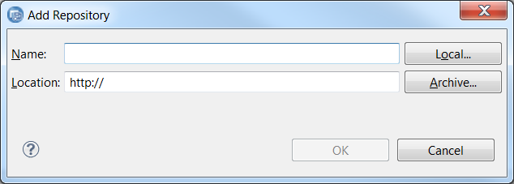
3. Select the Local button, and navigate to the location of the eclipse update site  
   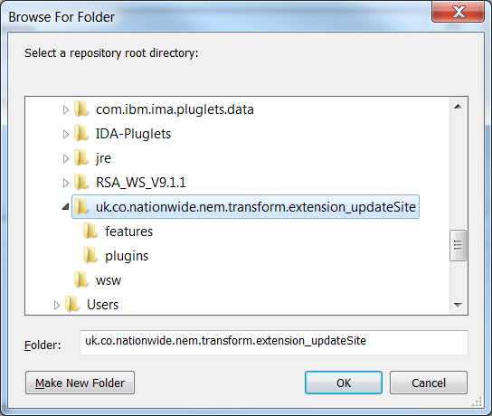
4. Select the folder **uk.co.nationwide.nem.transform.extension_updateSite** and hit OK.  
   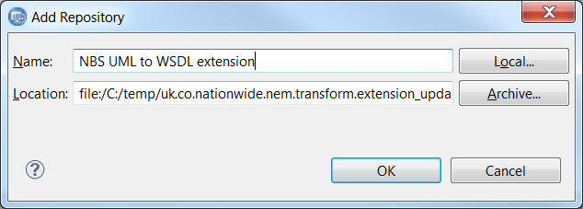
5. Give it a name (to allow easy selection again later if necessary) and hit OK. You will be returned to the Install wizard  
   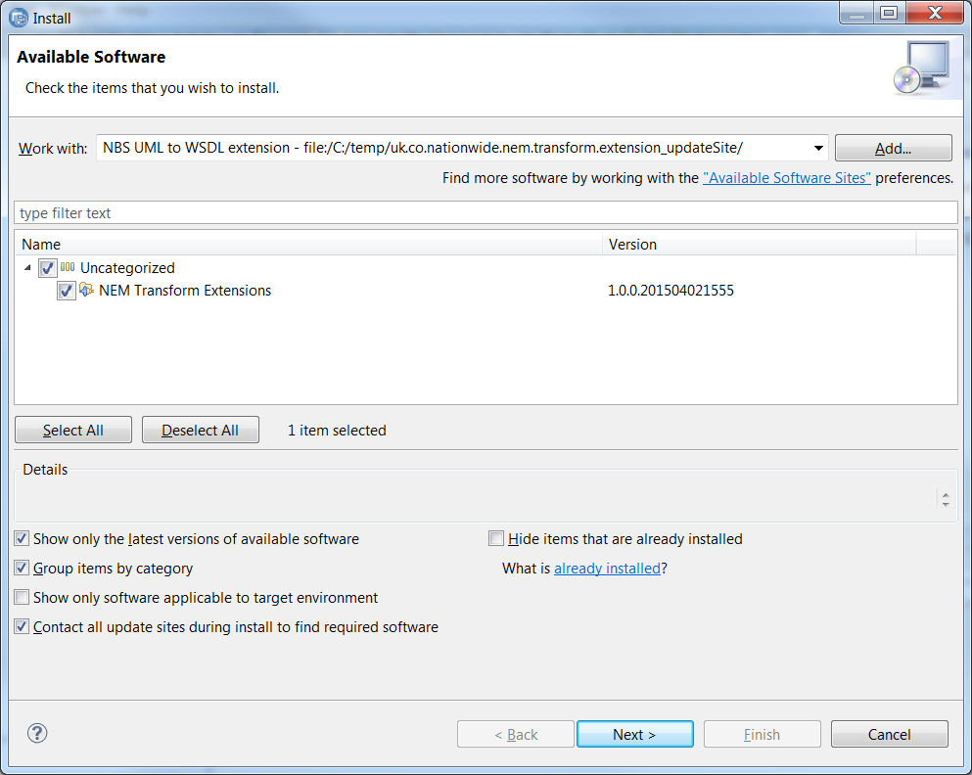
6. Select your new update site (if not selected) and check the box for the **NEM Transform Extensions** and hit Next.  
   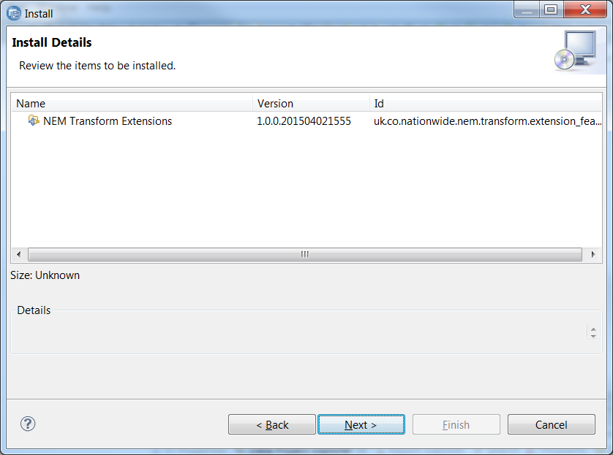
7. When asked to review the items to be installed, hit Next again  
   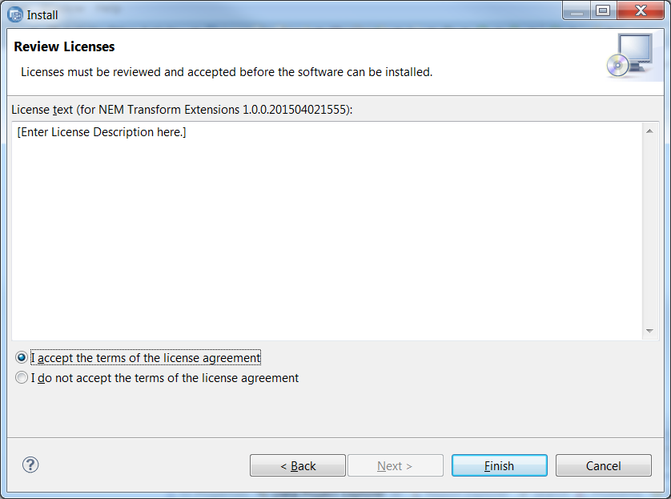
8. Accept the terms of the (empty) license agreement and hit Finish  
   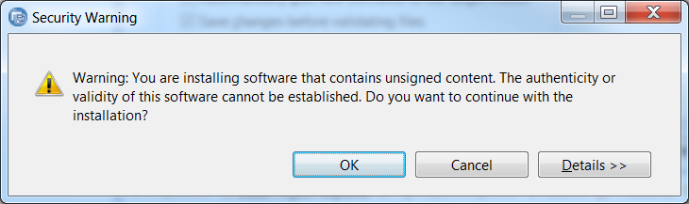
9. Accept the Security Warning by hitting OK. The installation will commence  
   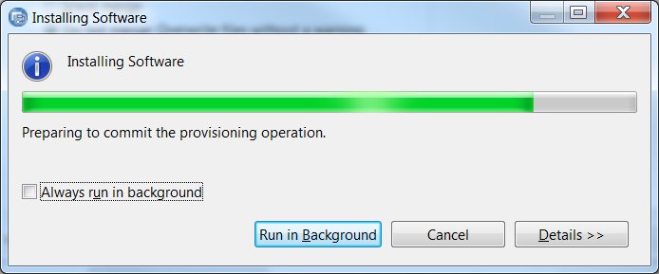
10. RSA will require a re-start to provide the extension.  
    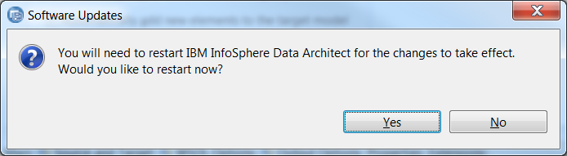
11. Select Yes to re-start RSA

# Running the UML to WSDL transform with NBS Rule Extensions

The following steps should be performed alongside the usual UML to WSDL transformation configuration steps:

1. Enable the NBS extension in the UML to WSDL Transformation configuration by checking the option in the **Extensions** tab  
   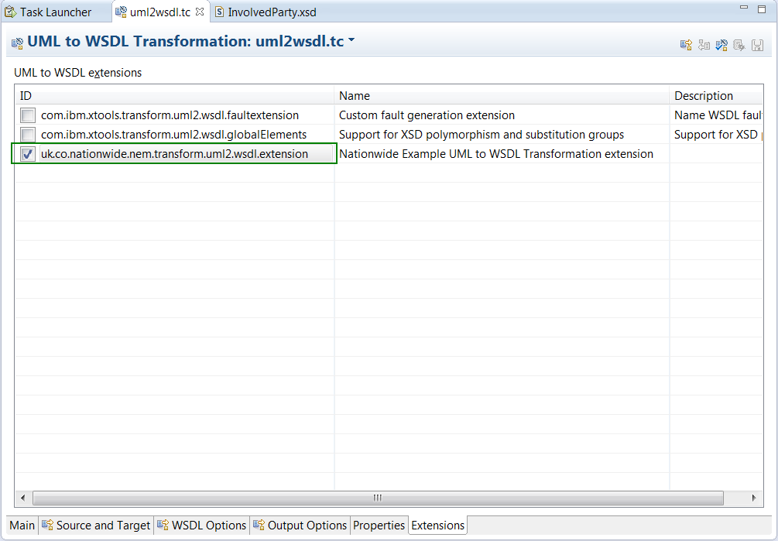
2. Switch to the **Main** tab and set the Merge options to **Visual merge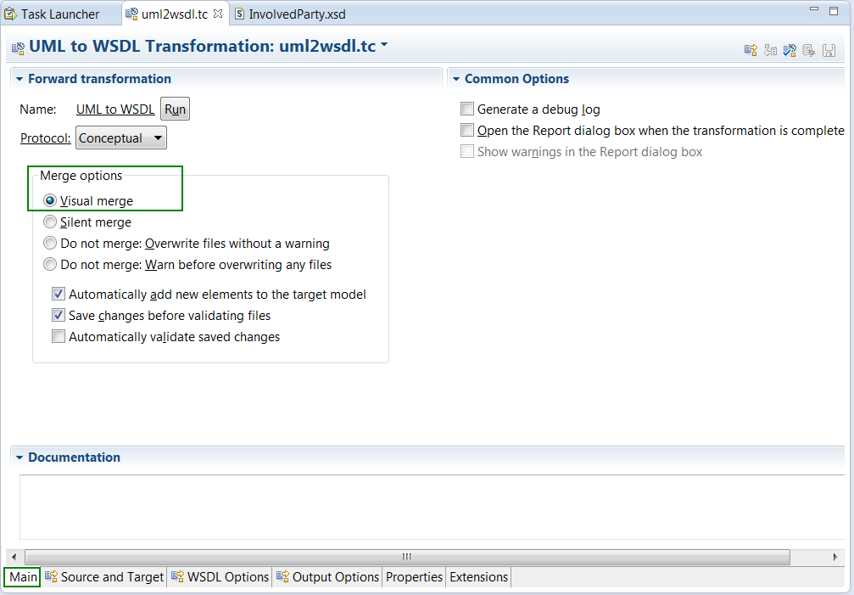 NB: The extension will not work without this option being selected**
3. Got to the **Properties** tab and select (if desired) an option for the NEM XSD Generation Type  
   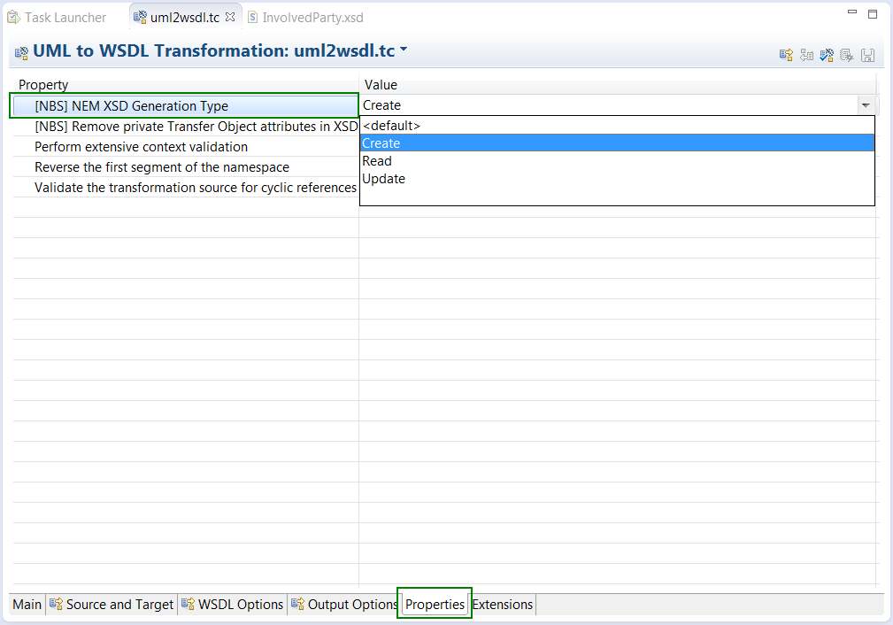
4. Still in the **Properties** tab, select (if desired) the option to Remove private Transfer Object attributes in XSD  
   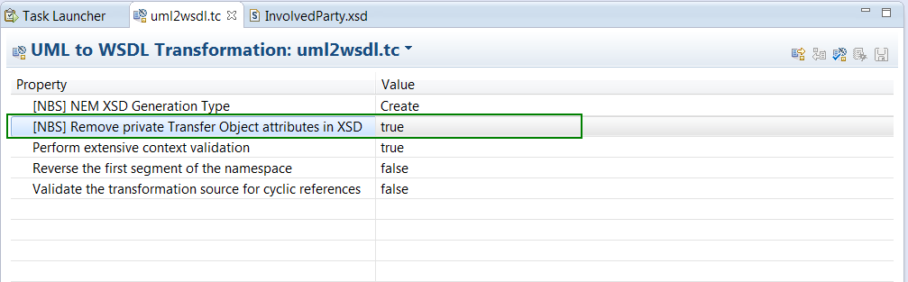
5. Run the transform configuration to complete the UML to WSDL/XSD transform

# Explanation of the Transformation Extensions

## [NBS] NEM XSD Generation Type

This option allows us to select a **Generation Type** from {<Default>, Create, Read, Update}, allowing for **keyword** based override of attribute cardinality

* If running in <Default> mode, no keyword based transform override will occur (option is ignored)
* If an attribute in a TO has keywords in {createRequired, readRequired, updateRequired} and the corresponding generation type is selected, then the lower bounds will be set to 1 in the XSD, regardless of the modelled cardinality in the TO
* If an attribute in a TO has keywords in {createOptional, readOptional, updateOptional} and the corresponding generation type is selected, then the lower bounds will be set to 0 in the XSD, regardless of the modelled cardinality in the TO
* If an attribute in a TO has keywords in {createAbsent, readAbsent, updateAbsent} and the corresponding generation type is selected, then the lower bounds will be set to 0 in the XSD, regardless of the modelled cardinality in the TO

## [NBS] Remove private Transfer Object attributes in XSD

This is a generic option which is applied **independently of the Generation Type** **option**

* This option instructs the transformation to simply exclude private TO attributes after a generation i.e. as a scoping alternative to hollowing out (deleting attributes from) Transfer Objects.
* Any attribute set to *private* in the Transfer Objects will be excluded from the transformation

**NB:** This isn't a true replacement of the existing transform logic, rather it whizzes over the XSD post out-of-the-box transform and updates/removes content from the XSD before its written. As such there's a couple of warnings:

Here's an example for Involved Party, with both rules invoked (Generation Type is **Create** and private attributes rule is enabled)

# Example Transformation

The image below depicts a sample input and output:

* *[NBS] NEM XSD Generation Type* is set to **Create**
* *[NBS] Remove private Transfer Object attributes in XSD* is set to **True**

